# 

# **Template – Student Course Drop Form**

The template named “Template – Student Course Drop Form” is applicable to CampusNexus Student.

## Purpose and Outcome

This template provides a form sequence and supporting workflow for a course drop form to be submitted by a student. The sequence requires the following:

* A complete **Student record** must exist in the CampusNexus Student database.
* The student must be **enrolled** in a program version at the institution.
* The student must have courses that are **scheduled** for a term.
* The student must have a **Portal login** to log into this authenticated sequence.

Upon completion of the sequence:

* A PDF file of the submitted course drop form is created and added to the student’s documents in Contact Manager.
* The student’s course status is updated to indicate that the course was dropped.
* The course drop action is recorded in the workflow log.

## Prerequisites

The template was built in Forms Builder using the applications listed below. The template is forward compatible with later versions of the listed applications.

|  |  |
| --- | --- |
| **Application** | **Minimum Version** |
| Forms Builder Designer and Renderer | 3.4 |
| Web Client for CampusNexus Student | 19.0 |
| Workflow Composer | 2.6 |
| Packages installed from Package Manager in Workflow Composer | Activities and Contracts (V1) 19.0.0  Activities and Contracts (V2) 19.0.0  Forms Builder Contracts 3.4 |
| Workflow Tracking Database | N/A |
| Staff STS 2.0 | 2.0 |

## Step 1: Download and Import the Template

1. Download the template file to your environment (local drive or network location).
2. Log into **Forms Builder Designer**.
3. Click the **Export/Import** tile.
4. Select the **Import** tab.
5. Click **Select exported file** and navigate to the downloaded template file.
6. Click **Import**.

* [Export/Import](https://help.campusmanagement.com/FB/3.x/Content/ExportImport.htm)

## Step 2: In Form Designer…

1. From the **Forms** slide out, select the **Student Course Drop Form**.
2. Customize the form for your environment. Modify properties on current fields to make them required, etc., or add/remove fields on form.

Make sure you edit the text in the Labels and HTML controls as applicable for your institution.

* [Fields](https://help.campusmanagement.com/FB/3.x/Content/Fields.htm) and [Components](https://help.campusmanagement.com/FB/3.x/Content/Components.htm)

1. **Save** the form.
2. The **Course Drop – End State** is a custom End State Form that is created when the sequence is imported. If you want to change the confirmation message, select the form from the Forms slide out, edit the text in HTML component, and save the form.

## Step 3: In Sequence Designer…

1. Select the **Student Course Drop Sequence**.

The sequence contains the following forms:

* Student Course Drop Form
* Course Drop - End State

1. Click **Save As** to create a copy of the sequence/workflow and customize the copy for your use. This way you can always refer to the original sequence/workflow you downloaded.
2. Optional - Add a custom style (theme) associated with your campus.

* [Themes](https://help.campusmanagement.com/FB/3.x/Content/Themes.htm)

1. Select your sequence in the Sequences pane.
2. In the Properties Pane:
   * Ensure that the **Authentication Product** is **Student**.

* Select the **End State Form** named **Course Drop - End State**.

1. **Save** the sequence**.**
2. Open the associated sequence workflow.

Depending on your environment, to open Workflow Composer either click **Open Workflow** in Sequence Designer or launch of a local installation of Workflow Composer.

* [Opening Workflows for Sequences](https://help.campusmanagement.com/FB/3.x/Content/HostedEnv.htm)

## Step 4: In Workflow Composer…

1. In the **Submit** transition, locate the **CreateDocument** activity.

Update **Document Type** and **Document Status** values as appropriate for your environment.

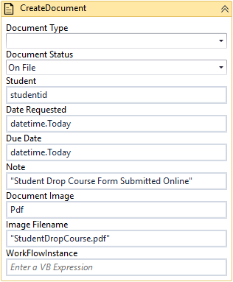

* [CreateDocument activity](https://help.campusmanagement.com/WF/Content/Workflow/CreateDocumentnew.htm)

1. For the **UserId** that is required in the ExecuteNonQuery activity in Submit transition (see next step), the workflow for the imported sequence uses a variable. The variable sets a default staff ID (value = 98) from the original database to push into the ExecuteNonQuery activity command.

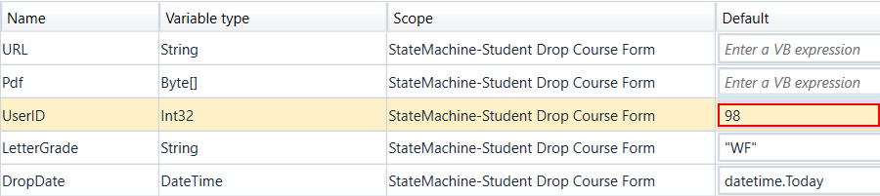

You can update the default value with a staff ID from your CampusNexus Student database, **or** use the **LookupAdvisor** activity before the ExecuteNonQuery activity to find the staff ID.

If you use the LookuoAdvisor activity, you need to create a variable and use that variable in the ExecuteNonQuery command in place of the original UserID variable. The variable can be named the same, but the variable type would be different.

* [LookuoAdvisor activity](https://help.campusmanagement.com/WF/Content/Workflow/LookupAdvisornew.htm)

1. Further down in the Submit transition, locate the **ExecuteNonQuery** activity with DisplayName “Exec Proc to Drop Course” and make sure that the command does not have a hard-coded UserId. The command should be as shown below:

"exec c2ksp_AdDropClass @EnrollSchedID = " & studentCourseEntity.ID &", @DropDate = '"& DropDate &"', @LetterGrade = '" & LetterGrade & "', @UserID = "& UserID &", @AdCourseStatusChangeReasonID = " & studentCourseStatusChangeReasonEntity.Id

* [ExecuteNonQuery activity](https://help.campusmanagement.com/WF/Content/Workflow/ExecuteNonQuery.htm)

## Step 5: In Forms Renderer and CampusNexus Student…

Select your sequence and try it out!

* [Sequence List](https://help.campusmanagement.com/FB/3.x/Content/SequenceList.htm)

1. Find your **Student Course Drop Sequence** and copy the **URL** to the clipboard.
2. Log in to Portal as a **student** and complete the course drop form.
3. In CampusNexus Student, verify the student’s enrollment status indicates that course was dropped and that the course drop form PDF is added to the document list.

## Step 6: Lastly…

Once your updated sequence has been tested successfully, it is recommended that you disable the workflow for the original Template version.

1. In Workflow Composer, in the Server section of the ribbon, click **Open**.
2. Find the workflow named **Student Course Drop Sequence**.
3. Clear the **Enabled** check box and click **Save**.